[Scrum - metrics](http://being-sm.blogspot.com/2015/05/scrum-metrics.html)

They say you are what you measure! Having measurable goals is part of SMART objectives. I believe it is extremely important to think about what metrics your Scrum team wants to keep and track.   
  
Tracking the right set of metrics can help the team gel together, get them to self organize and analyze & improve their performance. Tracking wrong data points can create defensive attitudes within team members and can lead to hostile environment.  
  
I also believe it is extremely important to be transparent about what you are tracking. Transparency is part of 3 pillars of Scrum / Agile. Tracking metrics transparently helps build trust between the team and a Scrum Master. In order for teams to perform well, they need to have a shared vision of success. Being transparent about what is being measured and monitored helps create that shared vision of success.  
  
Here are a few things I like to keep track of as a Scrum Master 

* Intra-release data points:
  1. Velocity per sprint - I believe this is an interesting metric because it helps track whether the team velocity is increasing or decreasing. The team can use this data to aid their retrospective - this data can help track whether the changes a team made have paid off or not.
  2. Number of defects fixed per sprint - I believe in having a single backlog containing user stories and defects. If your team does not size defects, a raw number indicating how many defects were fixed in the sprint can help give similar information as the velocity chart. It can also be an indicator of product quality.
  3. Percentage of commitments met - I strongly believe in creating an environment where a team holds itself accountable for their commitments. Providing this data point usually feeds into a retrospective where the team can analyze whether they are consistently missing their commitments.
  4. Here is an example with #1, 2, and 3 plotted in a single chart:

[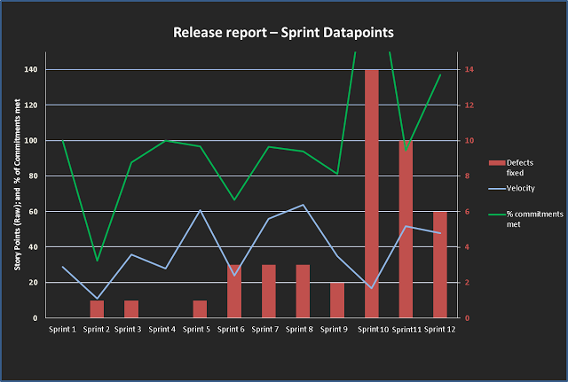](http://2.bp.blogspot.com/-YYYjFVNAgrw/VVKLB1EPZNI/AAAAAAAAD_w/ES_ICe-pH7A/s1600/Chart.png)

* Inter-release data points:
  1. Number of user stories committed to a release - This metric can help determine how many stories constitute a minimal feature set for each release. Maintaining this data for multiple releases can help track how it is changing.
  2. Number of defects targeted for a release - This metric, similar to the user story metric above, can help track how many defects you would like to fix in a minimal feature set based release; and how the data points are changing per release.
  3. Overall burn down / burn up in defects in the backlog - This metric can give a picture of inflow of defects over the period of the release. This can help track quality of the product built.

In general, if you want the Scrum team to take ownership of the product and be self organizing, you do NOT want to track individual metrics. Some examples of individual metrics are - time taken by each individual to fix a defect / story of a particular size; dividing team velocity by number of team members and assigning that number as velocity per individual; number of story points contributed by each team member etc. These metrics can not only be hard to track, but they also don't provide much information about the product. Tracking individual metrics and being transparent about it can cause competition between team-mates and lead to hostile environment.

Tracking metrics of team as a whole provides incentives to the team to co-operate with each other. This can lead to teams being comfortable asking for help when necessary in order to overcome obstacles.

I'd love to hear your thoughts on this, and also would like to know if you / your team tracks any other metrics, and the rationale behind it.